Lab # 01

Tasks
- List all files in the current directory.

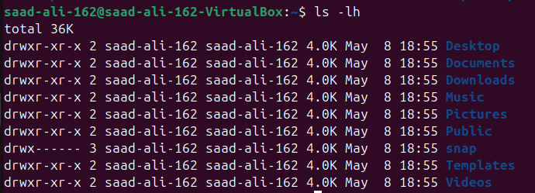
- List all files in human readable form.
- Display your current directory.
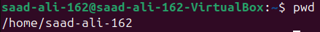
- Change to the / directory.
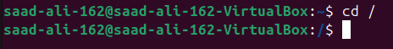
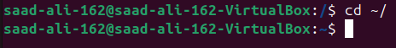
- Go to the ~ directory from the root directory.
- List the contents of the root directory.
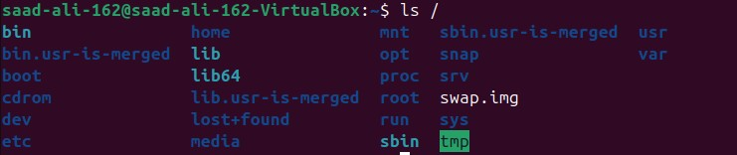

- List the files in /boot in a human readable format.
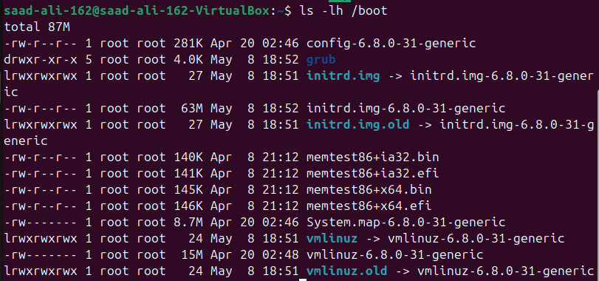

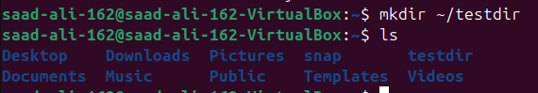
- Create a directory testdir in your ~ directory.
- Create in one command the directories ~/dir1/dir2/dir3 (dir3 is a subdirectory from dir2, and dir2 is a subdirectory from dir1 ).
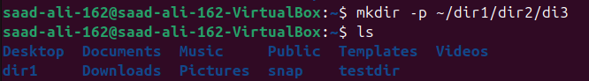

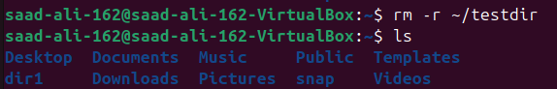
- Remove the directory testdir.

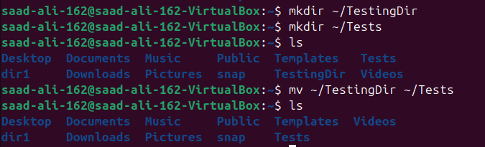
- Move TestingDir from ~ to ~/Tests directories.

- Rename a directory from TesingDir to testingDir
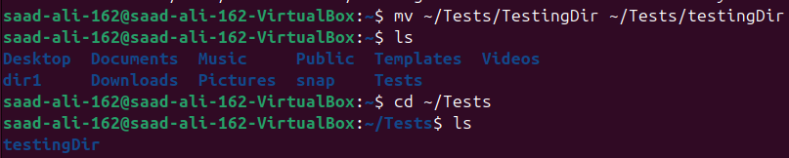

Tasks:

Lab # 02

- Use ls to output the contents of the /etc/ directory to a file called etc.txt.

- Make a file bioData.txt and check that it contains your name using grep,also use i & v flags.
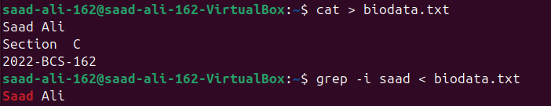

- Append information in bioData.txt.
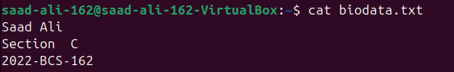

- Sort the file number.txt using flags.
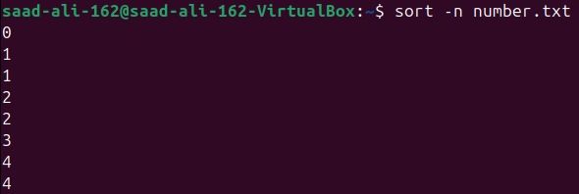

- Show all the information like total lines, total words and total character inside of your file.

- Change case of the letters of your file bioData.txt.
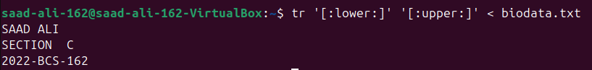

- Implement stderr (2> and 2>&1).
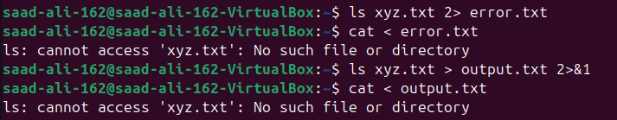

- Show last 5 data from numbers.txt
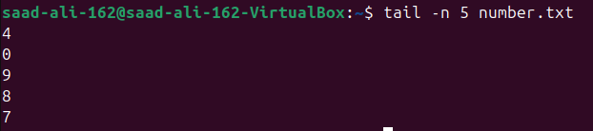

- Count all duplicates in your file bioData.txt
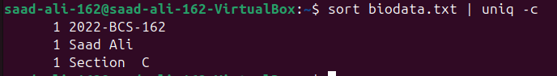

- Show your os version.
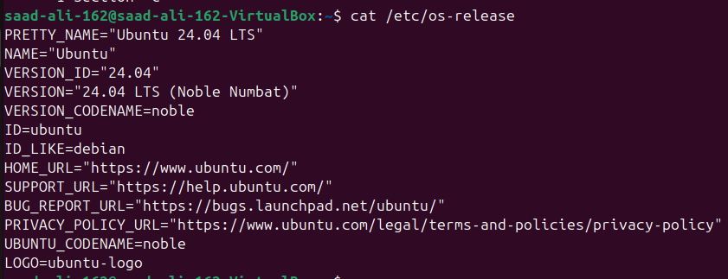
- Compress the file bioData.txt using gzip and bzip2 algorithm.

- Show contents of the file bioData.txt.gz without decompressing.
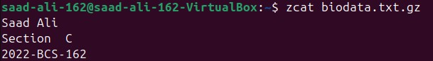

Lab # 03

Tasks:
- Create two groups webProject and SQA.

- Create two users , user1 and user2 and add them in a group webProject and SQA respectively.

- Show All users.
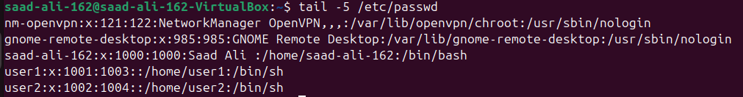

- Show All groups.
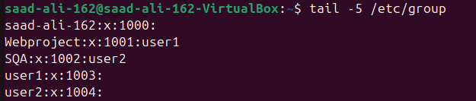

- Set user1 as group member of SQA.

- Switch to user2.

- Create a filename OSLabFile.txt and change its permission , read and execute only in group & user.

- Delete user1.
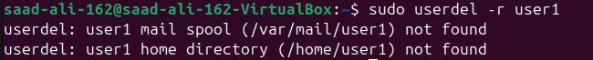

- Delete SQA.

- Change password of user1
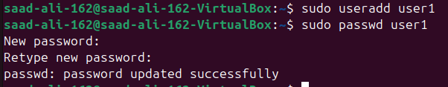

Lab # 04
Tasks:
- Create a MyInfo.txt using vi editor.

- Write Your name , roll number and section in MyInfo.txt.
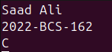

- Save the File.
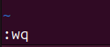

- Delete your section from MyInfo.txt.
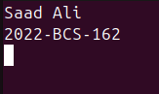

- Show content of MyInfo.txt using cat.
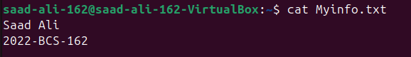
- Print host name

- Print your(system) user name.
- Show the locatoin where ls ,pwd ,rmdir & cat source code is present.
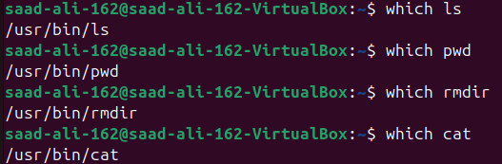

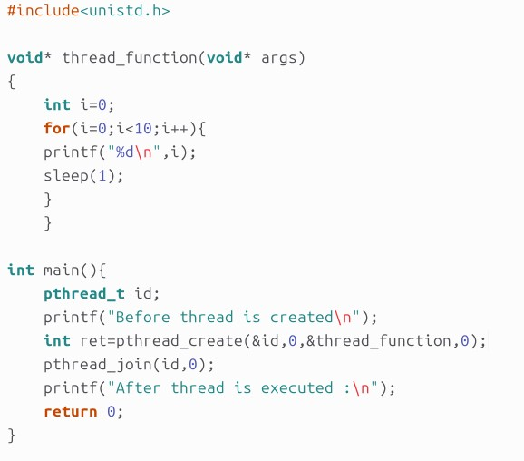

Tasks:

Lab # 05

- Create a file OSLabFile5.1 with date & time 25th January, 2025 3:00 PM.

- Find the binary and source file location of “ls” command

- Creates 5 threads each thread prints a "Hello World!" message, and then terminates.
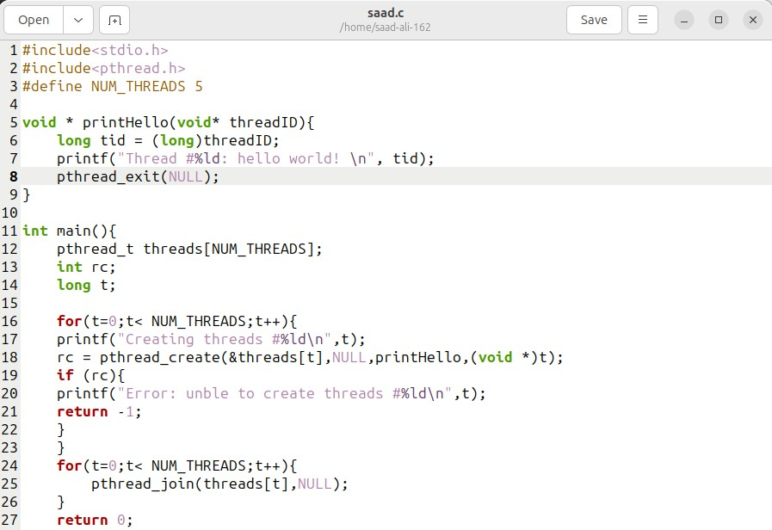

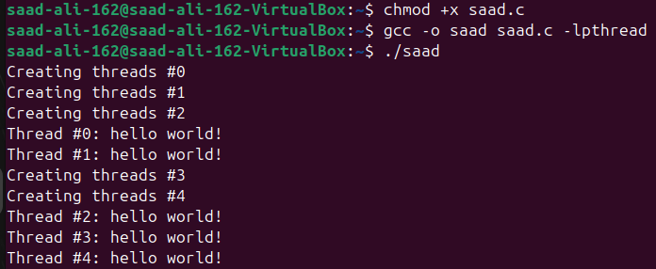

Lab # 06
FCFS:
us ng System;
us ng System.Collect ons.Gener c; publ c class flrocess
{
publ c nt Id { get; set; }
publ c nt Arr valT me { get; set; } publ c nt BurstT me { get; set; }
publ c nt Or g nalBurstT me { get; set; } publ c nt Wa t ngT me { get; set; }
publ c nt TurnaroundT me { get; set; }
publ c flrocess( nt d, nt arr valT me, nt burstT me)
{
Id = d;
Arr valT me = arr valT me; BurstT me = burstT me;
Or g nalBurstT me = burstT me; Wa t ngT me = 0;
TurnaroundT me = 0;
}
}
publ c class FCFS
{
publ c L st<flrocess> flrocesses { get; set; } publ c FCFS(L st<flrocess> processes)
{
flrocesses = processes;
}
publ c vo d Schedule()
{
nt currentT me = 0;
nt n = flrocesses.Count;
// Sort processes by arr val t me (though FCFS doesn't str ctly requ re th s) flrocesses.Sort((a, b) => a.Arr valT me.CompareTo(b.Arr valT me));
foreach (var proc n flrocesses)
{
// flrocess each job n arr val order f (proc.Arr valT me > currentT me)
{
currentT me = proc.Arr valT me;
}
proc.Wa t ngT me = currentT me - proc.Arr valT me; proc.TurnaroundT me = proc.Wa t ngT me + proc.BurstT me; currentT me += proc.BurstT me;
}
}
publ c vo d D splayResults()
{
nt totalWa t ngT me = 0;
nt totalTurnaroundT me = 0; Console.Wr teL ne();
Console.Wr teL ne("flrocess\tArr val\tBurst\tWa t ng\tTurnaround"); foreach (var proc n flrocesses)
{

Console.Wr teL ne($"{proc.Id}\t{proc.Arr valT me}\t{proc.Or g nalBurstT me}\t{proc.Wa t ngT me}\t
{proc.TurnaroundT me}");
totalWa t ngT me += proc.Wa t ngT me; totalTurnaroundT me += proc.TurnaroundT me;

}
float averageWa t ngT me = (float)totalWa t ngT me / flrocesses.Count;
float averageTurnaroundT me = (float)totalTurnaroundT me / flrocesses.Count; Console.Wr teL ne();
Console.Wr teL ne($"Average Wa t ng T me: {averageWa t ngT me:F2}"); Console.Wr teL ne($"Average Turnaround T me: {averageTurnaroundT me:F2}");
}
}
publ c class flrogram
{
publ c stat c vo d Ma n()
{
L st<flrocess> processes = new L st<flrocess>(); Console.Wr te("Enter the number of processes: ");
nt numberOfflrocesses = Convert.ToInt32(Console.ReadL ne()); for ( nt = 1; <= numberOfflrocesses; ++)
{
Console.Wr teL ne();
Console.Wr te($"Enter arr val t me for process { }: "); nt arr valT me = Convert.ToInt32(Console.ReadL ne());
Console.Wr te($"Enter burst t me for process { }: "); nt burstT me = Convert.ToInt32(Console.ReadL ne());
processes.Add(new flrocess( , arr valT me, burstT me));
}
// Create an FCFS scheduler
FCFS fcfs = new FCFS(processes);
// Schedule the processes fcfs.Schedule();
// D splay the results fcfs.D splayResults(); Console.ReadL ne();
}
}
SJF:
us ng System;
us ng System.Collect ons.Gener c; publ c class flrocess
{
publ c nt Id { get; set; }
publ c nt Arr valT me { get; set; } publ c nt BurstT me { get; set; }
publ c nt Or g nalBurstT me { get; set; } publ c nt Wa t ngT me { get; set; }
publ c nt TurnaroundT me { get; set; }
publ c flrocess( nt d, nt arr valT me, nt burstT me)
{
Id = d;
Arr valT me = arr valT me; BurstT me = burstT me;
Or g nalBurstT me = burstT me; Wa t ngT me = 0;
TurnaroundT me = 0;
}
}
publ c class ShortestJobF rst
{
publ c L st<flrocess> flrocesses { get; set; } publ c ShortestJobF rst(L st<flrocess> processes)
{
flrocesses = processes;
}
publ c vo d Schedule()

{
// Sort processes based on arr val t me, then burst t me flrocesses.Sort((a, b) => {
nt compareArr val = a.Arr valT me.CompareTo(b.Arr valT me); f (compareArr val == 0)
{
return a.BurstT me.CompareTo(b.BurstT me);
}
return compareArr val;
});
nt currentT me = 0;
nt completedflrocesses = 0; nt n = flrocesses.Count;
wh le (completedflrocesses < n)
{
// F nd the next shortest job that has arr ved flrocess shortestflrocess = null;
for ( nt = 0; < n; ++)
{
flrocess proc = flrocesses[ ];
f (proc.Arr valT me <= currentT me && proc.BurstT me > 0)
{
f (shortestflrocess == null || proc.BurstT me < shortestflrocess.BurstT me)
{
shortestflrocess = proc;
}
}
}
f (shortestflrocess != null)
{
// flrocess the shortest process found currentT me += shortestflrocess.BurstT me;
shortestflrocess.TurnaroundT me = currentT me - shortestflrocess.Arr valT me; shortestflrocess.Wa t ngT me = shortestflrocess.TurnaroundT me -
shortestflrocess.Or g nalBurstT me;
// Mark the process as completed shortestflrocess.BurstT me = 0; completedflrocesses++;
}

else
{

}
}
}

// If no process found to execute, just ncrement the t me currentT me++;

publ c vo d D splayResults()
{
nt totalWa t ngT me = 0;
nt totalTurnaroundT me = 0; Console.Wr teL ne();
Console.Wr teL ne("flrocess\tArr val\tBurst\tWa t ng\tTurnaround"); foreach (var proc n flrocesses)
{

Console.Wr teL ne($"{proc.Id}\t{proc.Arr valT me}\t{proc.Or g nalBurstT me}\t{proc.Wa t ngT me}\t
{proc.TurnaroundT me}");
totalWa t ngT me += proc.Wa t ngT me; totalTurnaroundT me += proc.TurnaroundT me;
}
float averageWa t ngT me = (float)totalWa t ngT me / flrocesses.Count;
float averageTurnaroundT me = (float)totalTurnaroundT me / flrocesses.Count;

Console.Wr teL ne();
Console.Wr teL ne($"Average Wa t ng T me: {averageWa t ngT me:F2}"); Console.Wr teL ne($"Average Turnaround T me: {averageTurnaroundT me:F2}");
}
}
publ c class flrogram
{
publ c stat c vo d Ma n()
{
L st<flrocess> processes = new L st<flrocess>(); Console.Wr te("Enter the number of processes: ");
nt numberOfflrocesses = Convert.ToInt32(Console.ReadL ne()); for ( nt = 1; <= numberOfflrocesses; ++)
{
Console.Wr teL ne();
Console.Wr te($"Enter arr val t me for process { }: "); nt arr valT me = Convert.ToInt32(Console.ReadL ne());
Console.Wr te($"Enter burst t me for process { }: "); nt burstT me = Convert.ToInt32(Console.ReadL ne());
processes.Add(new flrocess( , arr valT me, burstT me));
}
// Create a SJF scheduler
ShortestJobF rst sjf = new ShortestJobF rst(processes);
// Schedule the processes sjf.Schedule();
// D splay the results sjf.D splayResults(); Console.ReadL ne();
}
}
  - For below processes, write FCFS and SJF processes to calculate waiting time for each process and average waiting time.

Process | Arrival Time | Execute Time
P0 | 0 | 5
P1 | 1 | 3
P2 | 2 | 8
P3 | 3 | 6
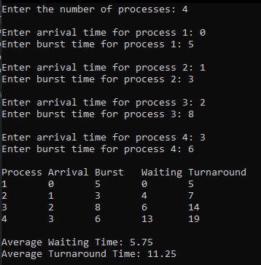
FCFS:

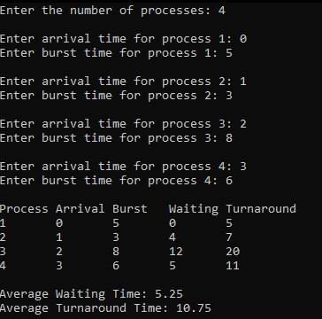

  - For below processes, write FCFS and SJF processes to calculate waiting time for each process and average waiting time.
Process | Arrival Time | Execute Time
P0 | 2 | 6
P1 | 5 | 2
P2 | 1 | 8
P3 | 0 | 3
P4 | 4 | 4

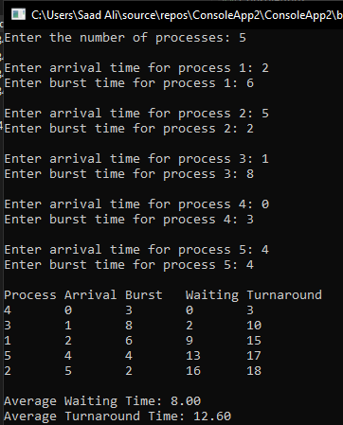
FCFS:

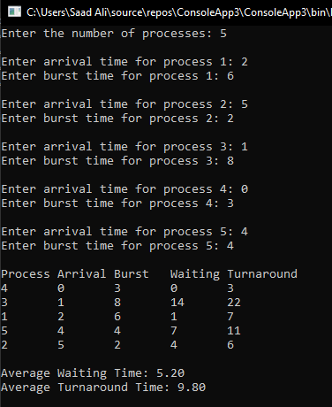

Lab # 07
ROUND ROBIN:
us ng System; class GFG
{
publ c stat c vo d roundRob n(Str ng[] p, nt[] a, nt[] b, nt n)
{
// Result of average t mes nt res = 0;
nt resc = 0;
// For sequence storage Str ng seq = "";
// Copy the burst array and arr val array for not affect ng the actual array nt[] res_b = new nt[b.Length];
nt[] res_a = new nt[a.Length];
for ( nt = 0; < res_b.Length; ++)
{
res_b[ ] = b[ ];
res_a[ ] = a[ ];
}
// Cr t cal t me of system nt t = 0;
// For store the wa t ng t me nt[] w = new nt[p.Length];
// For store the Complet on t me nt[] comp = new nt[p.Length];
wh le (true)
{
bool flag = true;
for ( nt = 0; < p.Length; ++)
{
// These cond t ons are for f arr val s not on zero
// Check that f they come before quantum t me f (res_a[ ] <= t)
{
f (res_a[ ] <= n)
{
f (res_b[ ] > 0)
{
flag = false;
f (res_b[ ] > n)
{
// Make decrease the burst t me t = t + n;
res_b[ ] = res_b[ ] - n; res_a[ ] = res_a[ ] + n; seq += "->" + p[ ];
}
else
{
// For last t me t = t + res_b[ ];
// Store complet on t me comp[ ] = t - a[ ];
// Store wa t ng t me w[ ] = t - b[ ] - a[ ];
res_b[ ] = 0;
// Add sequence
seq += "->" + p[ ];
}
}

}
else f (res_a[ ] > n)
{

them
// If any process has less arr val t me than the current process, execute

for ( nt j = 0; j < p.Length; j++)
{

// Compare
f (res_a[j] < res_a[ ])
{
f (res_b[j] > 0)
{
flag = false;
f (res_b[j] > n)
{
t = t + n;
res_b[j] = res_b[j] - n; res_a[j] = res_a[j] + n; seq += "->" + p[j];
}
else
{
t = t + res_b[j]; comp[j] = t - a[j]; w[j] = t - b[j] - a[j]; res_b[j] = 0;
seq += "->" + p[j];
}
}
}
}
// Now the prev ous process accord ng to th process f (res_b[ ] > 0)
{
flag = false;
// Check for greater burst t mes f (res_b[ ] > n)
{
t = t + n;
res_b[ ] = res_b[ ] - n; res_a[ ] = res_a[ ] + n; seq += "->" + p[ ];
}
else
{
t = t + res_b[ ]; comp[ ] = t - a[ ];
w[ ] = t - b[ ] - a[ ];
res_b[ ] = 0;
seq += "->" + p[ ];
}
}
}
}
else f (res_a[ ] > t)
{
t++;
--;
}
}
// Ex t the wh le loop f (flag)
{

break;
}
}
Console.Wr teL ne();
Console.Wr teL ne("process\tct me\twt me"); for ( nt = 0; < p.Length; ++)
{
Console.Wr teL ne(" " + p[ ] + "\t" + comp[ ] + "\t" + w[ ]); res = res + w[ ];
resc = resc + comp[ ];
}
Console.Wr teL ne();
Console.Wr teL ne("Average wa t ng t me s " + (float)res / p.Length); Console.Wr teL ne("Average complet on t me s " + (float)resc / p.Length); Console.Wr teL ne("Sequence s l ke that " + seq);
}
// Dr ver Code
publ c stat c vo d Ma n(Str ng[] args)
{
// Get the number of processes from the user Console.Wr te("Enter the number of processes: ");
nt numflrocesses = nt.flarse(Console.ReadL ne());
// Name of the processes
Str ng[] name = new Str ng[numflrocesses]; for ( nt = 0; < numflrocesses; ++)
{
name[ ] = "p" + ( + 1);
}
Console.Wr teL ne();
// Arr val t me for every process
nt[] arr valt me = new nt[numflrocesses]; Console.Wr teL ne("Enter the arr val t mes:"); for ( nt = 0; < numflrocesses; ++)
{
Console.Wr te("Arr val t me for " + name[ ] + ": "); arr valt me[ ] = nt.flarse(Console.ReadL ne());
}
Console.Wr teL ne();
// Burst t me for every process
nt[] burstt me = new nt[numflrocesses]; Console.Wr teL ne("Enter the burst t mes:"); for ( nt = 0; < numflrocesses; ++)
{
Console.Wr te("Burst t me for " + name[ ] + ": "); burstt me[ ] = nt.flarse(Console.ReadL ne());
}
Console.Wr teL ne();
// Ǫuantum t me of each process
Console.Wr te("Enter the quantum t me: "); nt q = nt.flarse(Console.ReadL ne());
// Call the funct on for output
roundRob n(name, arr valt me, burstt me, q); Console.ReadL ne();
}
}

PRIORITY BASED:
us ng System; class flrogram
{
stat c nt totalprocess; stat c nt[][] proc;
stat c nt[] arr valt me; stat c nt[] burstt me; stat c nt[] pr or ty;
// Dr ver code
stat c vo d Ma n(str ng[] args)
{
// Get the number of processes from the user Console.Wr te("Enter the number of processes: "); totalprocess = nt.flarse(Console.ReadL ne()); proc = new nt[totalprocess][];
arr valt me = new nt[totalprocess]; burstt me = new nt[totalprocess]; pr or ty = new nt[totalprocess];
// Get arr val t me, burst t me, and pr or ty for each process for ( nt = 0; < totalprocess; ++)
{
Console.Wr teL ne();
Console.Wr te($"Enter arr val t me for process { + 1}: "); arr valt me[ ] = nt.flarse(Console.ReadL ne());
Console.Wr te($"Enter burst t me for process { + 1}: "); burstt me[ ] = nt.flarse(Console.ReadL ne());
Console.Wr te($"Enter pr or ty for process { + 1}: "); pr or ty[ ] = nt.flarse(Console.ReadL ne());
}
// In t al ze the proc array
for ( nt = 0; < totalprocess; ++)
{
proc[ ] = new nt[4];
proc[ ][0] = arr valt me[ ];
proc[ ][1] = burstt me[ ];
proc[ ][2] = pr or ty[ ];
proc[ ][3] = + 1;
}
// Sort by pr or ty and then by arr val t me Array.Sort(proc, (x, y) => x[2].CompareTo(y[2]));
Array.Sort(proc, (x, y) => x[0].CompareTo(y[0])); F ndgc();
Console.ReadL ne();
}
// Us ng FCFS Algor thm to f nd Wa t ng t me stat c vo d GetWtT me( nt[] wt)
{
// Declar ng serv ce array that stores cumulat ve burst t me nt[] serv ce = new nt[totalprocess];
// In t al s ng n t al elements of the arrays serv ce[0] = 0;
wt[0] = 0;
for ( nt = 1; < totalprocess; ++)
{
serv ce[ ] = proc[ - 1][1] + serv ce[ - 1];
wt[ ] = serv ce[ ] - proc[ ][0] + 1;
// If wa t ng t me s negat ve, change t to zero f (wt[ ] < 0)
{
wt[ ] = 0;
}

}
}
// F ll ng turnaround t me array
stat c vo d GetTatT me( nt[] tat, nt[] wt)
{
for ( nt = 0; < totalprocess; ++)
{
tat[ ] = proc[ ][1] + wt[ ];
}
}
stat c vo d F ndgc()
{
// Declare wa t ng t me and turnaround t me array nt[] wt = new nt[totalprocess];
nt[] tat = new nt[totalprocess]; nt wavg = 0;
nt tavg = 0;
// Funct on call to f nd wa t ng t me array GetWtT me(wt);
// Funct on call to f nd turnaround t me GetTatT me(tat, wt);
nt[] st me = new nt[totalprocess]; nt[] ct me = new nt[totalprocess];
st me[0] = 1;
ct me[0] = st me[0] + tat[0]; Console.Wr teL ne();

Console.Wr teL ne("flrocess_no\tStart_t me\tComplete_t me\tTurn_Around_T me\tWa t ng_T me");
// Calculat ng start ng and end ng t me for ( nt = 0; < totalprocess; ++)
{

tat[ ]
wavg += wt[ ]; tavg += tat[ ];
Console.Wr teL ne(proc[ ][3] + "\t\t" + st me[ ] + "\t\t" + ct me[ ] + "\t\t" +

+ "\t\t\t" + wt[ ]);
// D splay the process deta ls f ( != totalprocess - 1)
{

st me[ + 1] = ct me[ ];
ct me[ + 1] = st me[ + 1] + tat[ + 1] - wt[ + 1];
}
}
Console.Wr teL ne();
// D splay the average wa t ng t me and average turn around t me
Console.Wr teL ne("Average wa t ng t me s: " + (double)wavg / totalprocess); Console.Wr teL ne("Average turnaround t me s: " + (double)tavg / totalprocess);
}
}

- Perform the above code with 8 Number of processes by randomly setting the arrival time and burst time and priority.
- Use Round Robin Algorithm
- Use Priority Based Algorithm

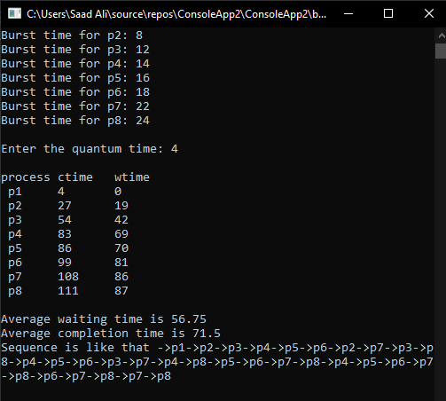
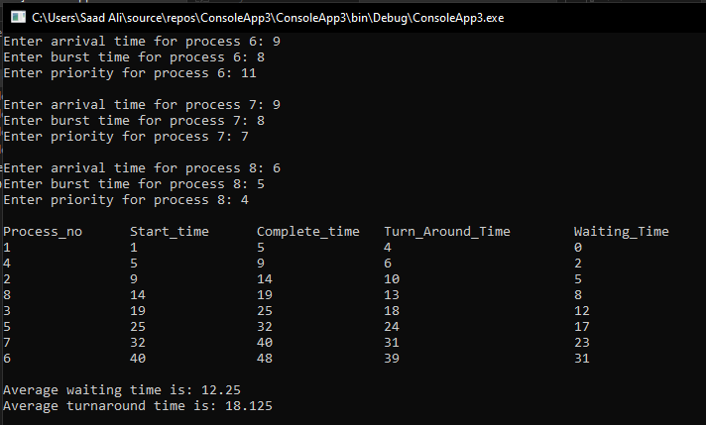

- Perform the above code with 10 Number of processes by randomly setting the arrival time and burst time and priority.
- Use Round Robin Algorithm
- Use Priority Based Algorithm
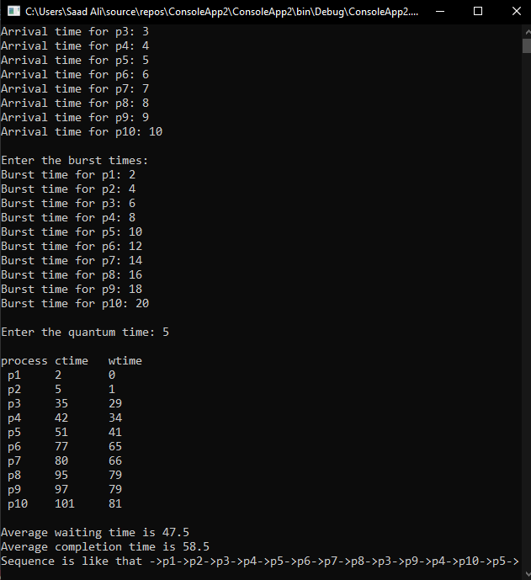

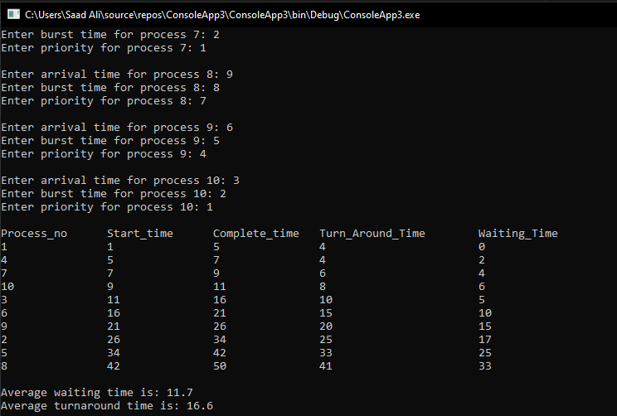

Lab # 10
- Take two inputs from user and then perform arithmetic operations
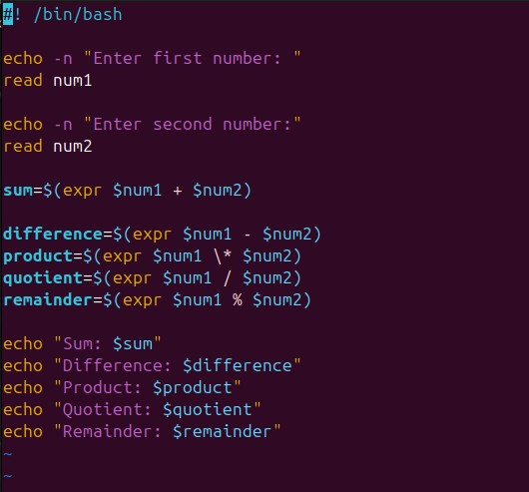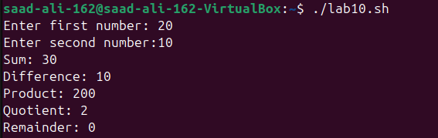
- Use system variables and user defined variables to show how that value can be accessed.

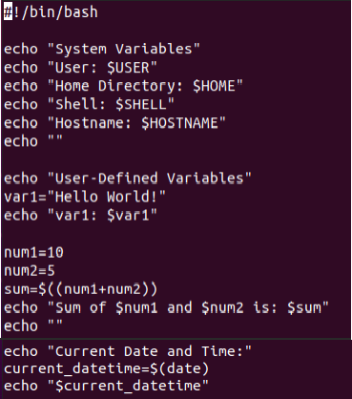
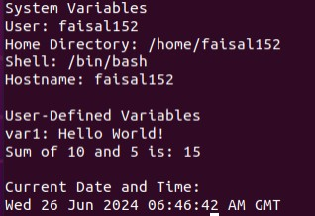
- Show results of double , single and back quote.
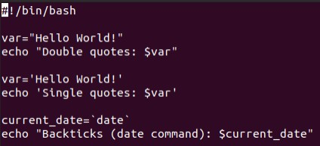

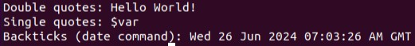

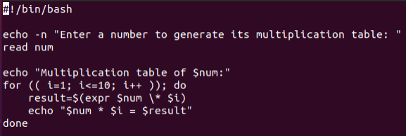

Lab # 11
- Write a program to generate the following output by using while loop The value of x is 10
The value of x is 9 The value of x is 8 The value of x is 7 The value of x is 6 The value of x is 5 The value of x is 4 The value of x is 3 The value of x is 2 The value of x is 1
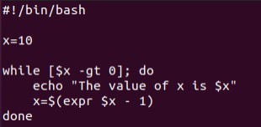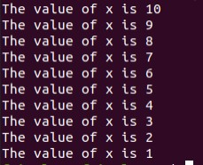
- Write a program to generate the table of any number by using for loop.

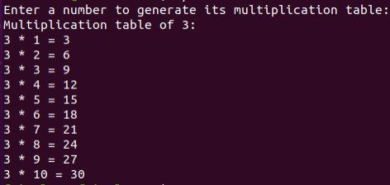
- Write a program to generate the factorial of a number.
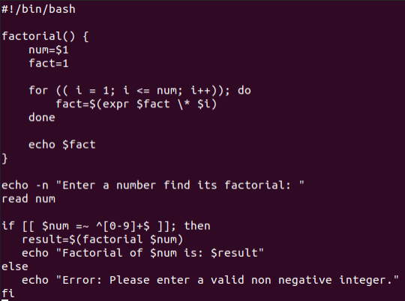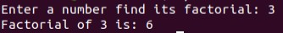
- Write a program to show the grades and % of students (with students details).

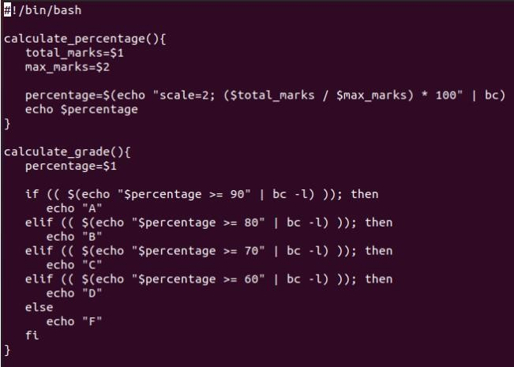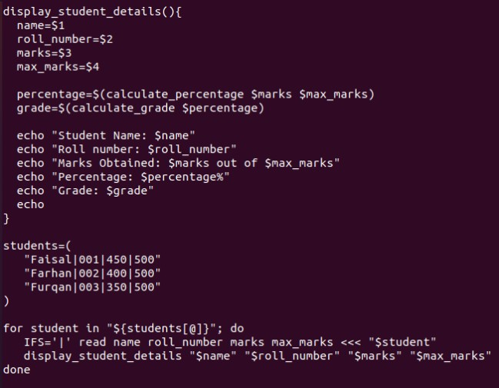

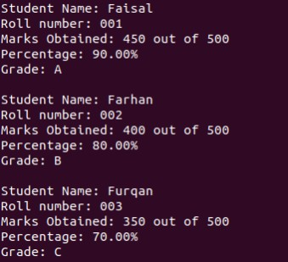

Lab # 13a
- Write a Bash script that takes a username as an argument and prints the user's ID, home directory, and login shell using switch case.
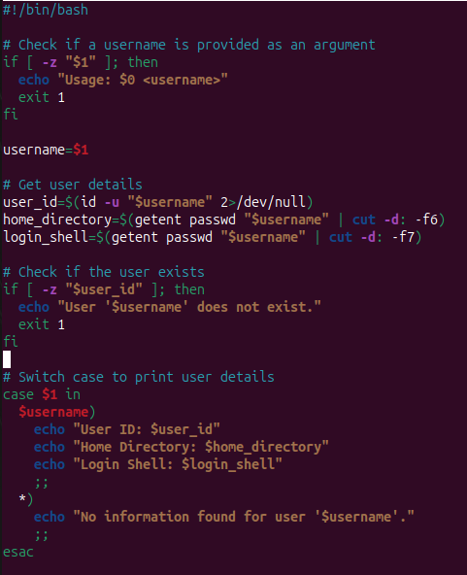
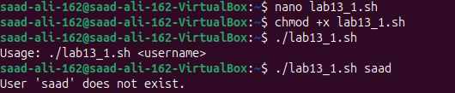

- Write a Bash script that takes three arguments: two numbers and an operator (+, -, *, /). The script should perform the calculation and print the result handle by using switch case .
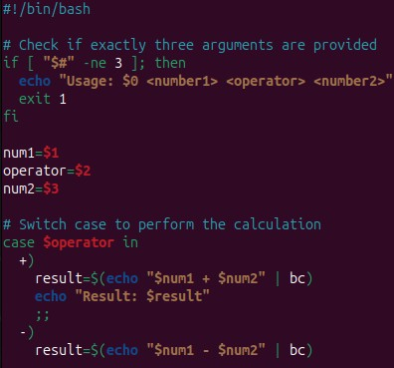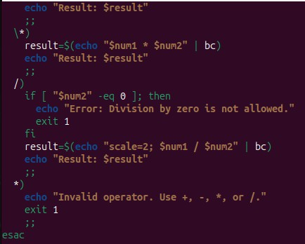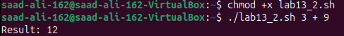

- Write a Bash script that counts and prints the number of files in a given directory and its subdirectories handle by using switch case.
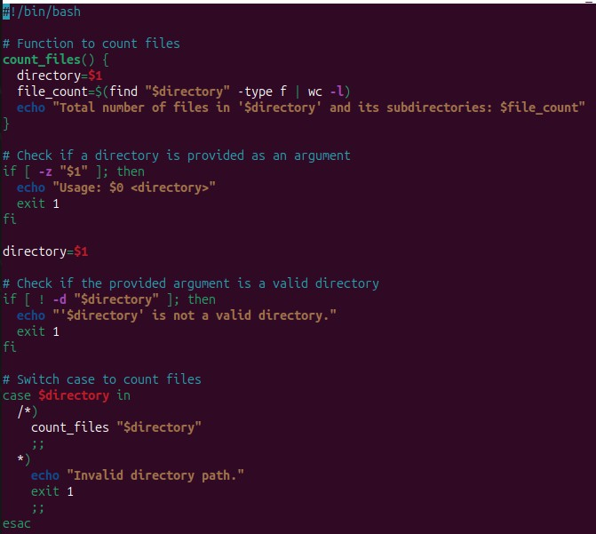

Lab # 13b
  - Implement all the above logic using functions
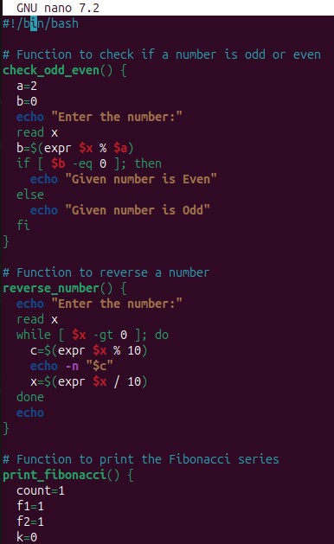
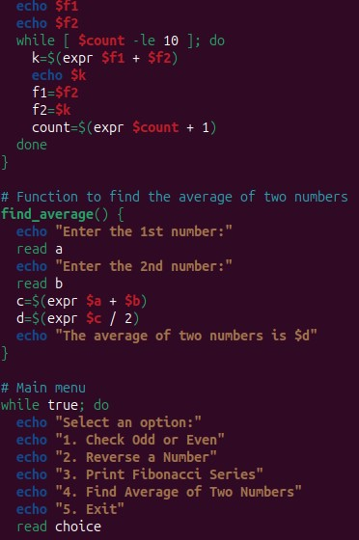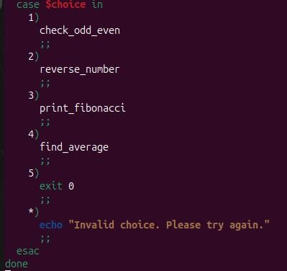

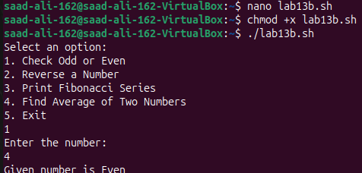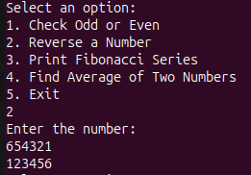
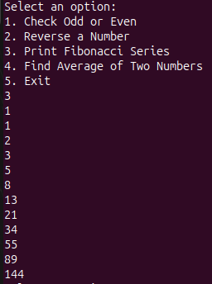
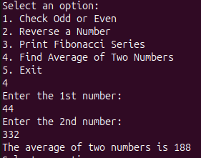

Lab # 14
Demonstrating Hello World Example
Pre-requisite
Create an account with DockerHub Open PWD Platform on your browser
Click on Add New Instance on the left side of the screen to bring up Alpine OS instance on the right side

